PROJECTDESIGNPHASEI SOLUTIONARCHITECTURE
ProjectName: |  |  | Real-Time River Water Quality Monitoring
ProjectName: |  |  | and Control System
Members |  |  | Abiyavincy D  Berlin K  Jemilda J  Kerin Shinu VS

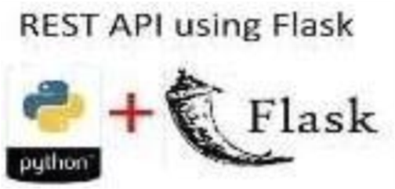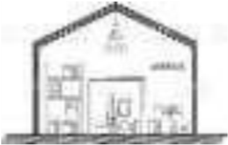
DeploymentinIBMcloud
Containerizetheapp
Specifiedsoftware
User
Tracker
Storescustomers
Detailsandinventory
stocks
OnlineMonitor
Supplier
Mobile
Serveroncloud
CloudDatabase
Datawarehouse
Stockholder

